**Movie Ticket Management System**

Detailed description of table and the relationship between data in them

In this document we discussed about the structure of each table and also discussed the changes that we made in the transition from ER diagram to database creation

Entities:

Customer Tables:

Since Customer Table has an attribute named Phone Number which can have multiple values to avoid redundancy we choose to decompose it into two different tables, one contains all the details about Customer and the other table contains the CustID and Phone Number where the Primary key is (Customer ID + Phone Number) and Customer ID is foreign key

Customer

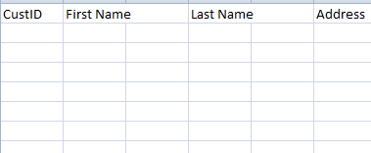

CustPhone

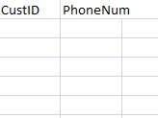

CustID and PhoneNum together is primary key

CustID is foreign key

Movie Table:

Decomposed into 2 tables

Table 1: Movie ID, Movie Name and Movie Duration

Table 2: Movie ID,Movie Date, Movie Time

MovieTable1

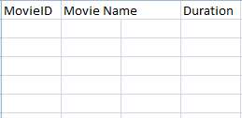

Movie Table 2:

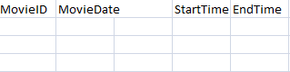

Primary Key: Movie ID+ Start Time

(We are not including Movie Date into primary key as we are considering all the shows on a particular date, we have chosen 15-10-2022 as our date of booking)

Ticket Booking Table:

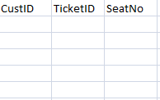

CustID is foreign Key and Ticket ID is multivalued so

Primary key(CustID, TicketID)

(Removed no of tickets from table as it can be retrieved using "count")

Ticket ID in ticket booking data:  
The Ticket ID is alphanumeric,to find which customer booked a ticket to which theatre the ticket ID is divided into 3 parts

**7RSTPQ23451**

Here the red part in ticket ID represents the theater number, if any customer books a ticket for a theater having ID 7 then the ticket ID corresponding will start with 7. The Green part represents the Customer Specific Value, whenever a customer books a ticket then that ticket will contain his specific string of alphabets. The pink numeric part represents the ticket number, as a customer can book any number of tickets for a movie, this number determines each specific value for each ticket he or she books.. We have another Attribute named Seat number which actually determines the Seat in the theater.

Payment Table:

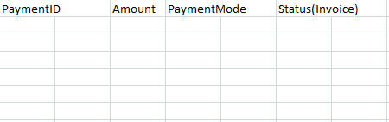

Theatre:

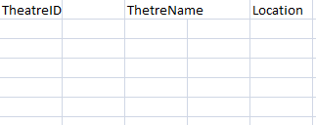

Relationships:

Select:

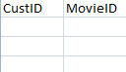

Customer “selects” movie

Book:

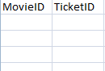

Ticket is “Booked” for Movie

Choose:

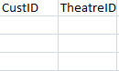

Customer “Chooses” theater

Choose, Select and Book relation’s data is merged into the same file

Made:

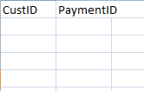

Customer “Made” Payment

For:

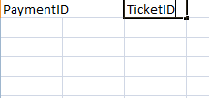

Payment “for” booking ticket

Made and For Relation’s data is merged into same file